CURRENT STATUS OF THE BOSSONS MARKET
A Plea for help to all Bossons Collectors
Especially Members of the
International Bossons Collectors Society (IBCS)

By Donald M. Hardisty D.M.A.
IBCS Memberships #65 (3/29/83 and #525 (1/28/87)
www.bossons.us

It is imperative that avid Bossons collectors take notice and help alleviate copyright infringements, unauthorized colorings, and fraudulent copies confronting the Bossons collecting world today. If we truly care about these original art forms, created for our enjoyment and lasting value, a constant vigilance is necessary.

Looking at the Past
As we know, the late William Henry Bossons founded Bossons in 1946. When he died in 1951, his son, W. Ray Bossons took charge as Director. In 1958, Ray oversaw the designing of our first “Character Wall Masks.” Like his father, he made certain standards were maintained and the authenticity of the Bossons creations were not only of the highest quality, but protected against unauthorized paintings and copies.

I personally witnessed Ray’s determination to eliminate any illegal copies of Bossons. In 1984, I saw hundreds of chalk copies of military masks, Series B heads, and many of the wildlife Bossons stored in apple boxes under the counters at the Hen House Ceramics in Alamogordo, New Mexico. We speculated that Bossons were replicated from those sold in the PX’s at Holloman Air Base and White Sands Missile Range. I told Mr. Bossons about the copies. He immediately sent the following letter to the Hen House Ceramics, 2902 No. White Sands, Alamogordo, New Mexico, USA, dated 13th September 1984:
“W. H, Bossons [Sales] Limited
Dear Sirs
We are the creators of original copyrighted Artware, particularly character wall heads, and we understand that your company is currently selling items that are copies of our models.
Your sale of these copies constitutes copyright infringement and unfair competition.
In order to avoid litigation in this matter we must have your immediate written assurances
that all sales of such copies will cease forthwith.
We trust that this matter will be amicably settled. However, if we do not receive your
assurances that sales of these infringing copies have ceased, we shall be obligated to take legal
action to seek both damages and injective relief.
Yours faithfully, W. Ray Bossons, Managing Director”

This was the response letter of the Hen House Attorney in Alamogordo dated September 27, 1984:
“Mr. W. Ray Bossons
W. H Bossons Sales Limited, Brook Mills, Congleton, Cheshire, CW12 1DQ

CURRENT STATUS OF THE BOSSONS MARKET
By Donald M. Hardisty, continued page 2

RE: Hen House Ceramics, Alamogordo, New Mexico, USA
Dear Mr. Bossons:
I have been requested to review your letter of September 13, 1984 and the enclosed information entitled “Character Wall Heads.”

Hen House Ceramics also wishes to avoid any litigation in this matter. Without making
a disclosure or admission as to any infringement, the Hen House Ceramics will discontinue use of any reproductions that may raise questions of copyright infringement.

Should you have questions in regard to this matter, please feel free to contact me.
Very truly yours, R. Randolph Burroughs, Attorney at Law

We visited the Hen House Ceramics a couple weeks later and noticed that all the apple boxes with their contents had disappeared from the shop. Further, I have more examples where Ray took other dealers to court and won suits against them. He was determined to protect Bossons from the illegal pirating of our collectibles. (Soon after this incident the Hen House went out of business).

The Challenge for Bossons Collectors
Ray Bossons retired in 1994 and died in May 1999. We are now left with a monumental problem of policing the industries and markets on our own. Jane Roberts Bossons, his daughter and attorney, directed the operations until closing in December 1996. After several attempts, we have been unable to elicit cooperation from any members of the Bossons family. I have personally written Mrs. Ruth Fraser Bossons. In her handwritten letter she was very gracious and kind, but declined to have any involvement saying that in the later years of her life she no longer wished to take an active interest in Bossons. Further, she had confidence the IBCS should be trusted to deal with these kinds of problems. Through direct verbal and written communications with Ken Potts over the years, it was consoling to know that under the direction of Jane Bossons, Ken assured me that the original molds he had stored under lock and key would never be copied or sold. In Ray’s latter years, Ken was one of the only life-long and trusted confidants who visited Ray’s side. Ken’s sudden passing October 2003, brought an end to that direct link with Bossons. Now all we can do is trust and unite in our efforts to maintain the integrity of Bossons throughout the collecting world. (You may read my Tribute to Ken in this link).

Since 1995, I have written annual survey articles on Bossons for the International Schroeder’s Antique Price Guides. In a prepublication draft for the 2008 Edition of this publication, I have addressed the problem in the following statement:
“…Bossons are no longer produced, and as such are becoming very collectible. Unfortunately,
unauthorized paintings and fraudulent moldings are circulating throughout the secondary markets
worldwide, especially on the Internet. We have tangible evidence of illegal copies of all categories
of Bossons being made and distributed from Pakistan. (Witness my extensive and documented video and sound lecture presented to the IBCS at the San Antonio meeting in 2003). [The Pakistan

CURRENT STATUS OF THE BOSSONS MARKET
By Donald M. Hardisty, continued page 3

Copies] include Character Masks of Caspian Woman, Gilded Winston Churchill and Wheatcroft; Wildlife that includes Squirrel, Raccoon and Chipmunks; and Dogs of Distinction, e.g., Bassett Hound and Alsation have been sold on the Internet by such sellers as ‘Uniquefinds14” who also
sells multiple series of Pakistan postage stamps on eBay! Know your suppliers/dealers and make certain they are well informed.”

But these written statements are not enough to prevent the proliferation of the frauds. Being fully aware that unauthorized paintings and fraudulent moldings are circulating throughout the secondary markets, we can excuse the innocent, who lack the background and experience in recognizing the fakes; however, it is especially serious when well-known collectors are seen buying these products on eBay. As members of the IBCS, we must make every possible effort to avoid buying these fake Bossons.

As time will allow, I continue to write these sellers using diplomatic and positive approaches to encouraging them to cease the selling of fraudulent and inferior Bossons products. The first step is starting to communicate with these individuals and ask their cooperation. Most often they are not well informed about Bossons. Here is a sample of one recent experience that can serve as an example of how one can solicit cooperation through ‘helpful’ comments.

The eBay Connection
To EBay I.D. imgallery I wrote under their eBay link of “ask seller a question:”

“I trust you are aware these figures are fraudulent copies of our Military Masks from Bossons.
Kindly help us rid eBay of these horrible copies of the ‘Imagical World of Bossons.’ I am always
ready to assist, should you request. Regards, Don Hardisty www.bossons.us”

After closing her auction, the seller identified herself and sent back these comments:
“Greetings, and thank you for the information…I appreciate it. When I purchased these pieces, I thought they were quite well made, and the finish on them, along with the detail was quite good. I had no idea what they were, and my knowledge about Bossons is negligible…I thought that I had seen Bossons on eBay which looked similar to these Pieces. I realized that these pieces were not signed, “Bossons,” but I thought that perhaps, some Bossons pieces were not signed. That is why I placed “Bossons type” in my listing, as I was not sure. There is a stamp on the back of each. Any idea what it says??? Anyway, my idea was NOT to mislead anyone. It is just that I have no knowledge in this field, and I did the best that I could. Feel free to get back to me. Thanks, Michele

I did reply to Michele assuring her that I realized she was not acquainted with Bossons and provided her with a descriptive analysis of quality Bossons. I also offered to send her photos for further clarification.

This is only one example of hundreds of emails and letters I have written just in the past year. We all must do the same. You will find a small minority of responses to your emails will be negative, and that is to be expected. However, continue to be positive and instructive.
CURRENT STATUS OF THE BOSSONS MARKET
By Donald M. Hardisty, continued page 4

Finally, if you are buying on eBay, and have any doubt about the authenticity and fail to get ADVANCE advice and assistance, I recommend very strongly that you NOT purchase the item. Quite often, after the fact, in email from amateur and knowledgeable collectors, there are questions as to whether they have purchased an original or a ‘knockoff.’

Comparative Quality Analysis
One of the most frequent examples of fakes being sold on eBay is with the CASPIAN WOMAN with and without veil. In fact, as I write this release for one of the BRIEFS (2-15-07), there are two fraudulent colorings of the Caspian Woman for sale on eBay.

Following are pictures, side-by-side of my original version followed by these appalling examples that recently appeared on eBay, and there are dozens everyday.

CURRENT STATUS OF THE BOSSONS MARKET
By Donald M. Hardisty, continued page 5

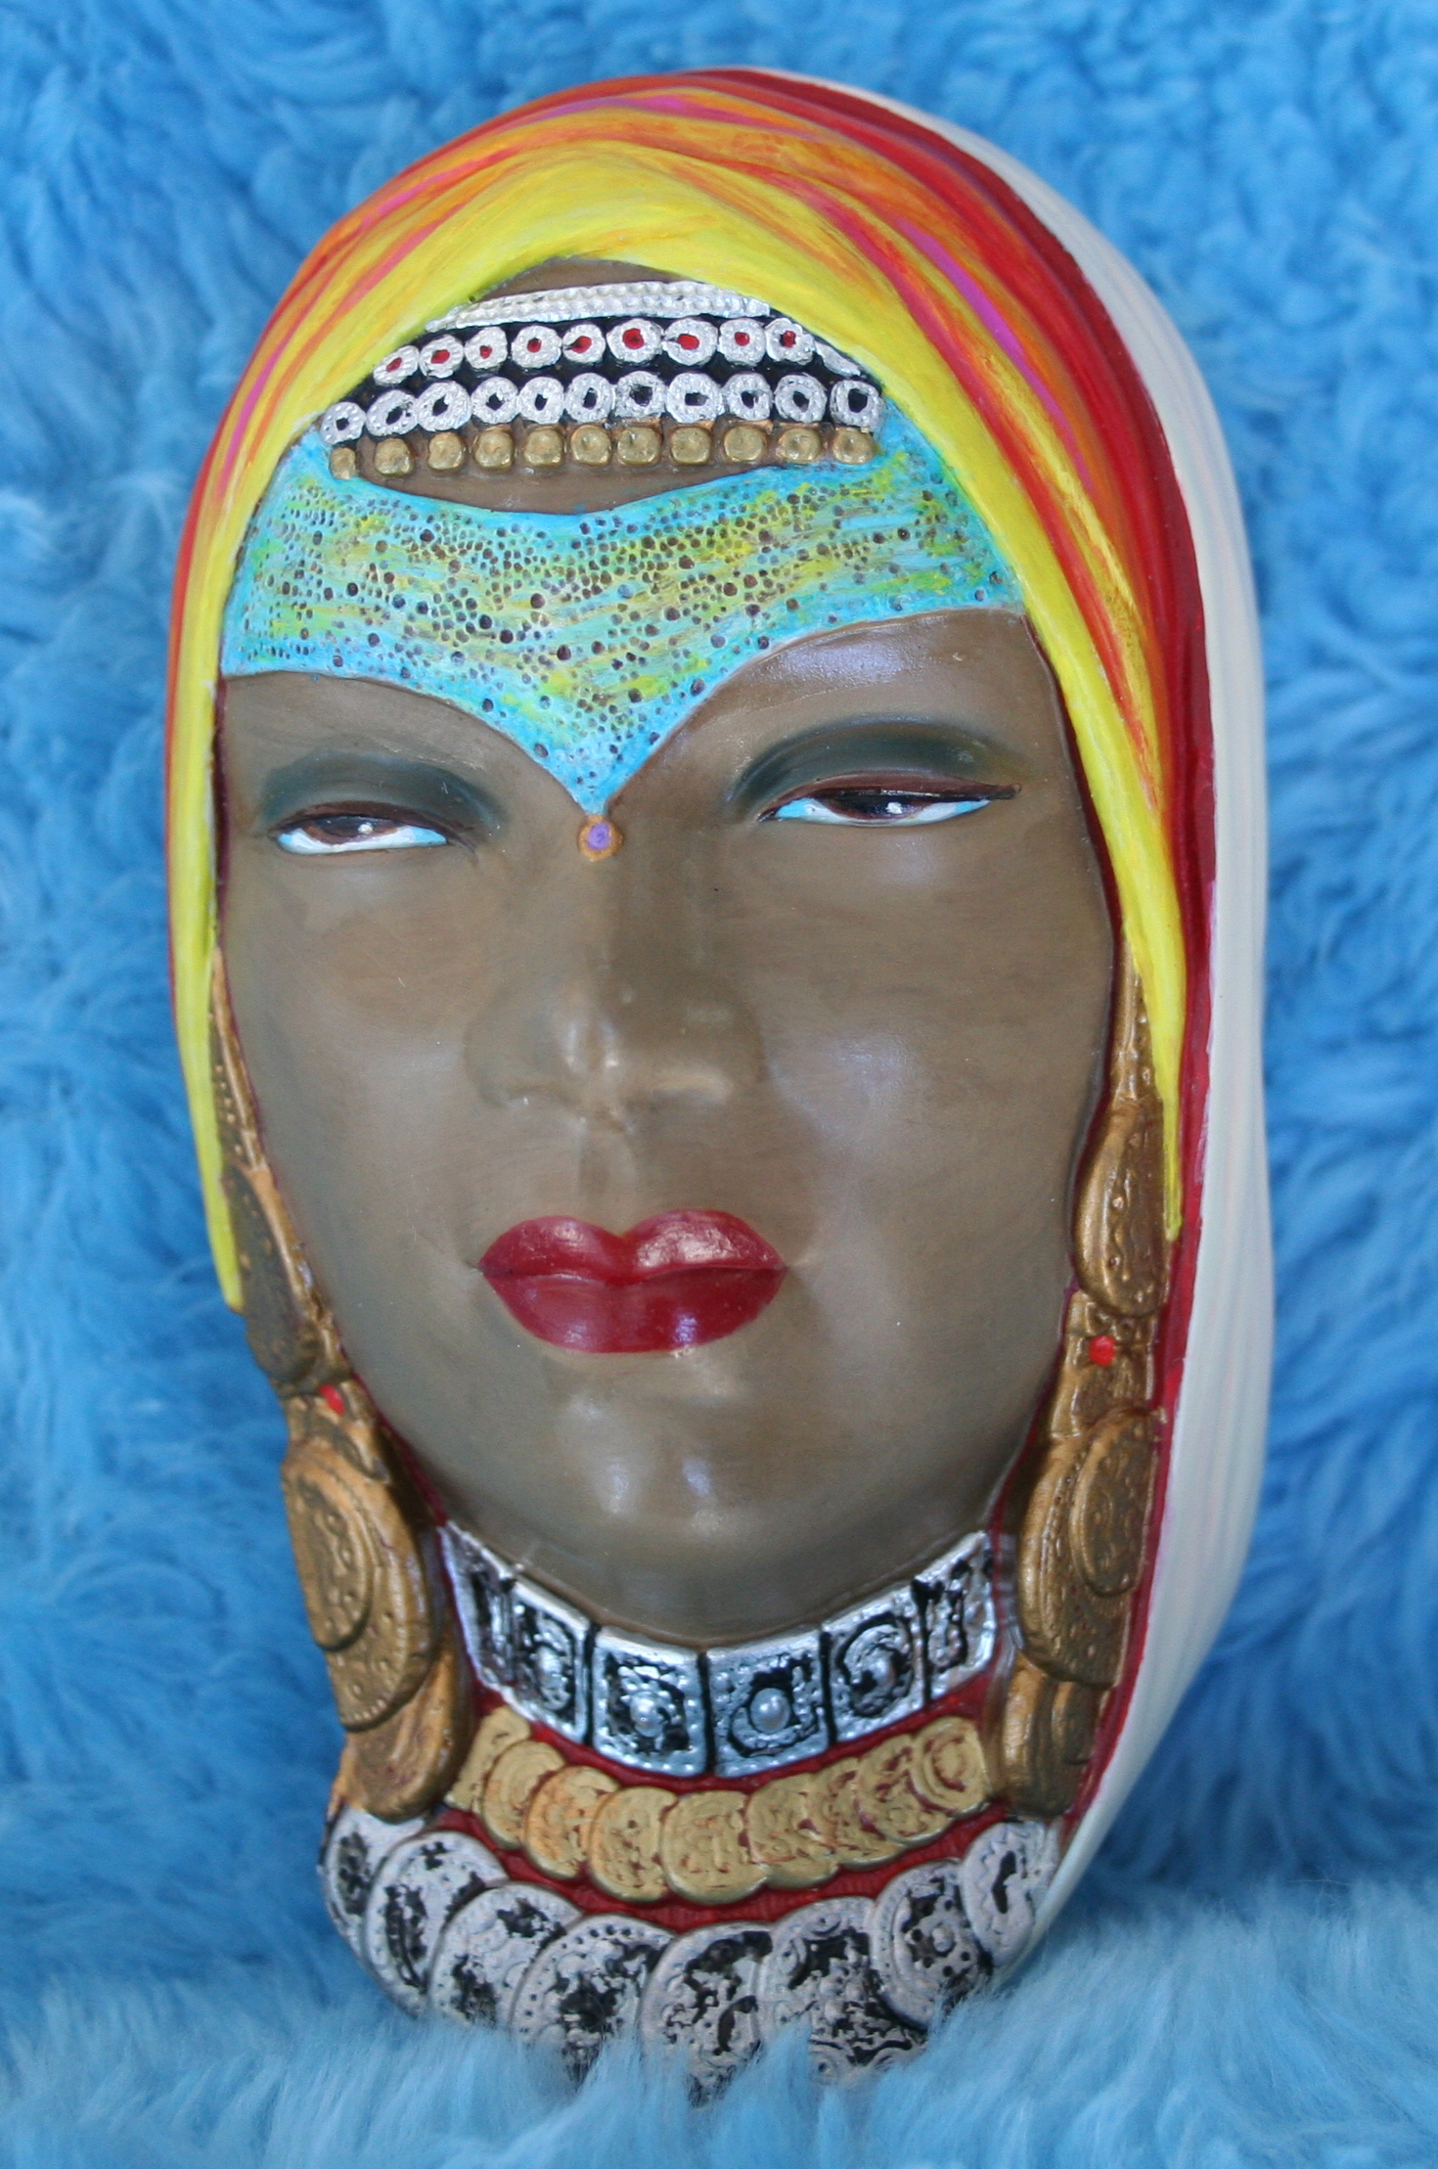

Don’s original Caspian Woman (copyright 1958) directly from Bossons is pictured above. It has an outside hanger, the FIRST TYPE used BEFORE Bossons used the ring hook. Make comparisons with the two following eBay auctions, dated February 15, 2007. As you compare, take note of the sharp detail in the gold and silver coins backed with magenta, the impeccable details in the facial veil, the multi- colored and the contrasting depth of ivory, blues and pinks shown in the outer headpiece. In particular, see the beauty of the semi-glossed face of light brown raw sienna, and the pink, and gray colors with highlights around the eyes, mouth and nose. With heavy shadows and sky blue coloring, the eyes appear to be almost seductive.

CURRENT STATUS OF THE BOSSONS MARKET
By Donald M. Hardisty, continued page 6

Two current eBay auctions of Caspian Woman with unauthorized paintings

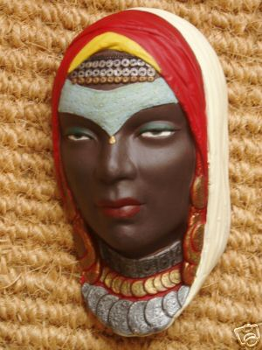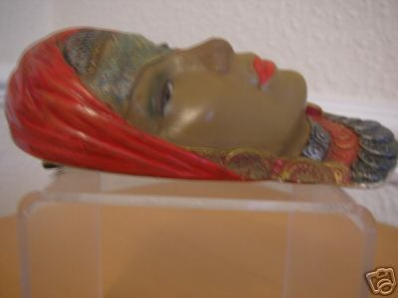

Both of these eBay auctions are being sold from the U.K. I call the first one shown above “Miss Chocolate Caspian,” and the one below “Miss Orange Caspian Woman.” I wrote both sellers telling them their auctions were not authentic and thus illegal colorings of the original 1958-59 Bossons Caspian Woman and offered to send them accurate pictures.

CURRENT STATUS OF THE BOSSONS MARKET
By Donald M. Hardisty, continued page 7

Supplementary pictures of Don’s original Caspian Woman without veil showing the mandatory incised copyright notice on the back side of the Bossons, and a side view showing the third- dimensional multiple coloring of the shawl.

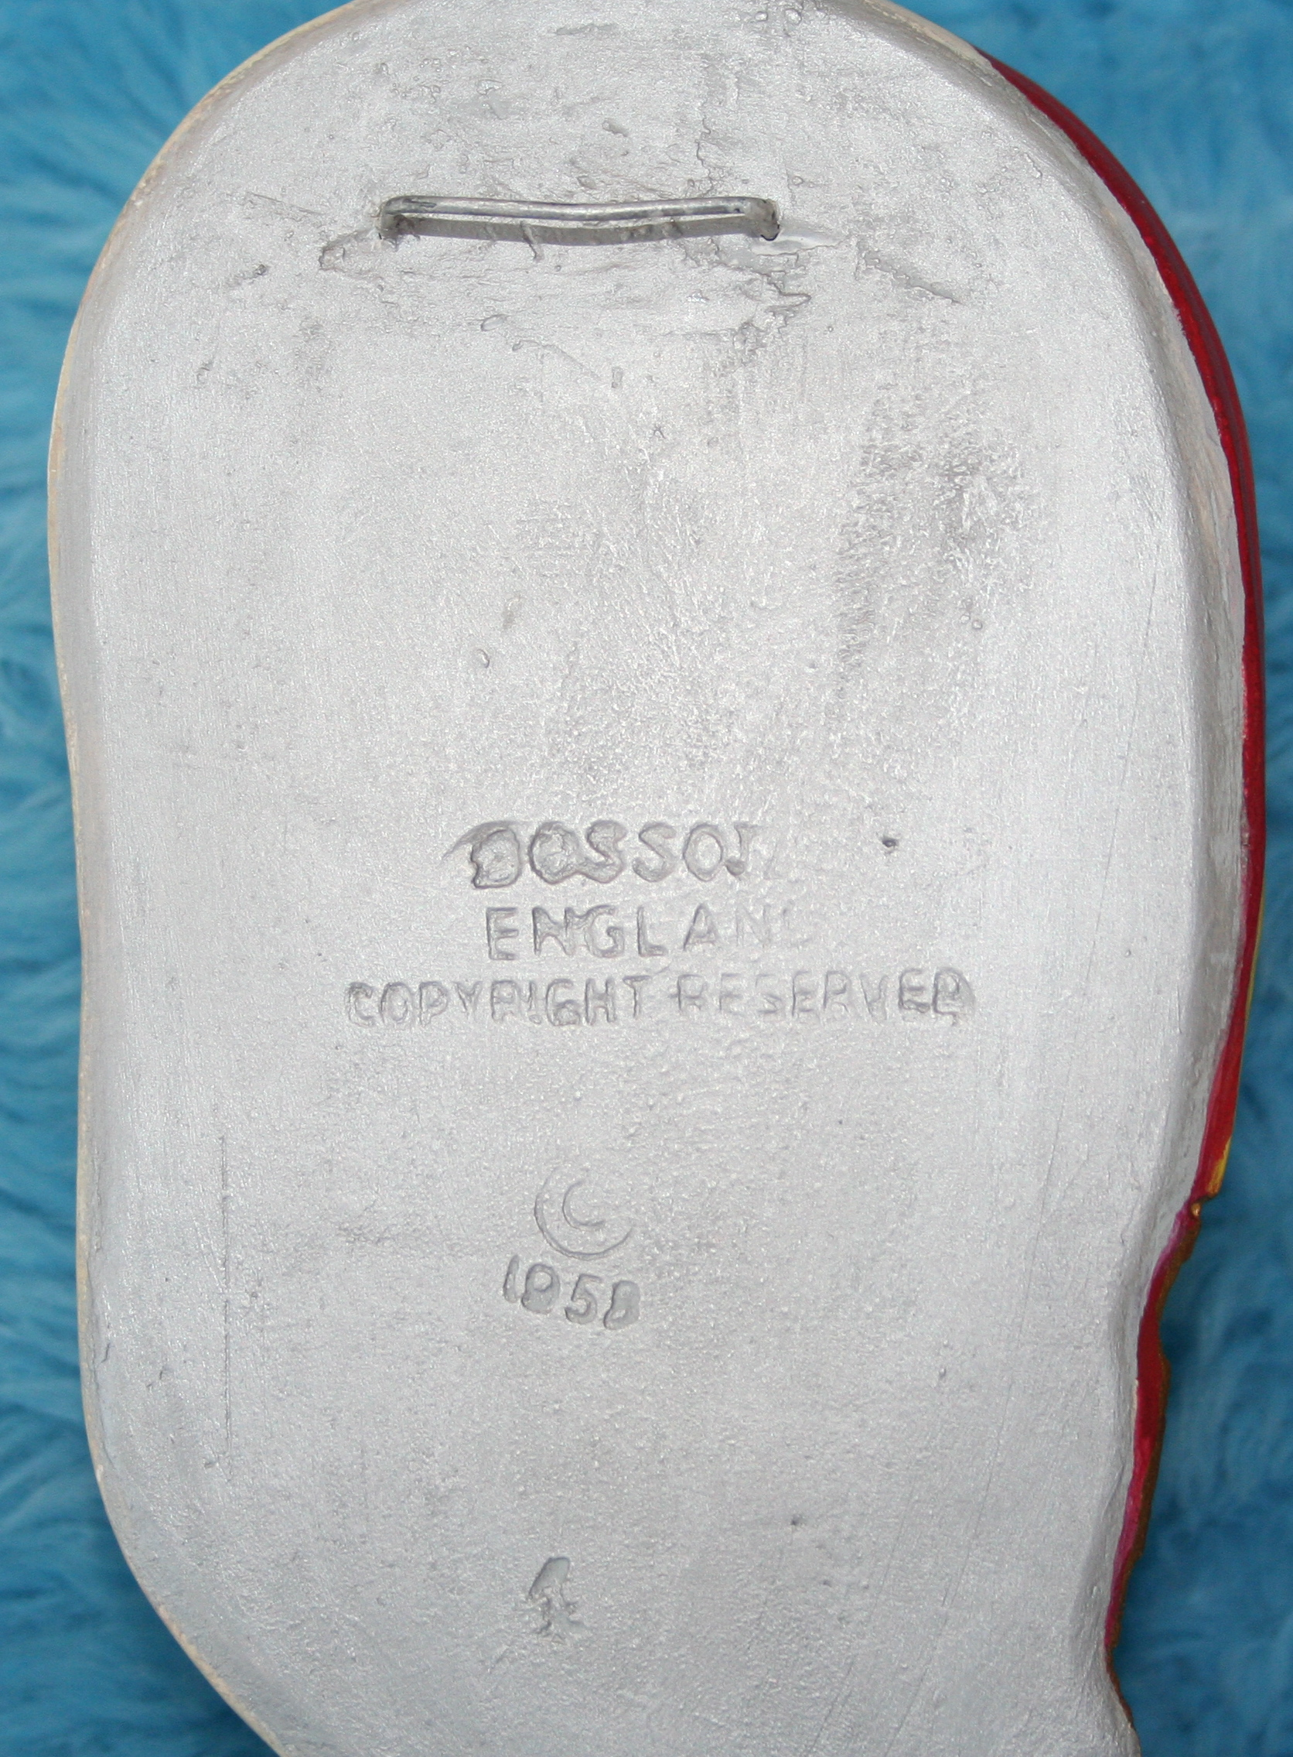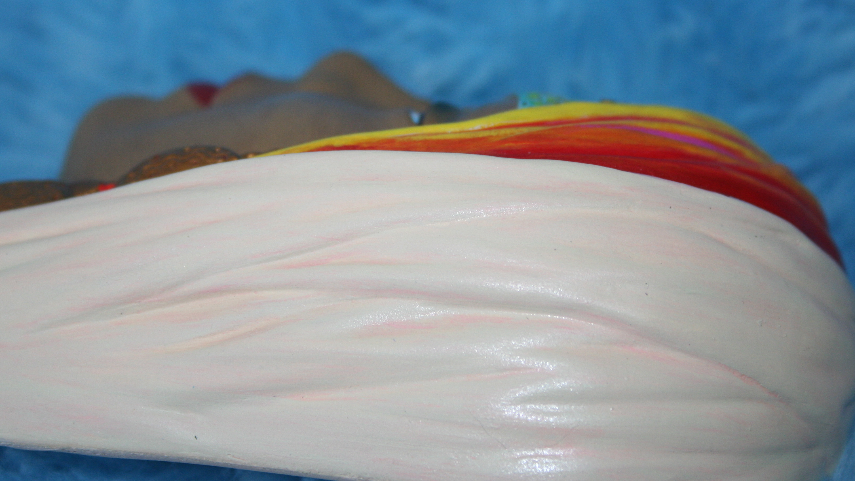

A Vital Quest For The Future
We must cast a bright light on our own activities making certain we do not perpetuate the distribution of inferior quality Bossons. IBCS members may look with anticipation to the goals, objectives, and implementation of strategy by a recently appointed IBCS FRAUD SQUAD.

Also I refer you to this link for an excellent study of Bossons and the proliferation of fakes and frauds on the internet by a highly capable and avid collector of Bossons, and friend, Jon Mclaughlin.

As we continue to honor the standards set by Ray Bossons, all collectors of authentic works of art are strongly encouraged to join together in keeping the world free of fraudulent imposters creeping their way into the
‘Imagical’ World of Bossons.’

